CARRERCRAFTER – JOB PORTAL

Table Users
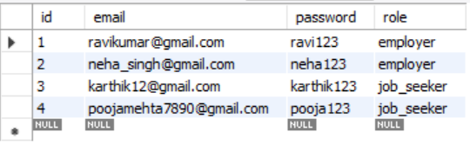

Table - Employers
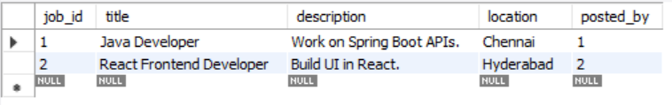

Table - Job_Seekers
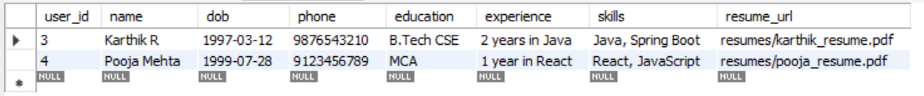

Table - Jobs
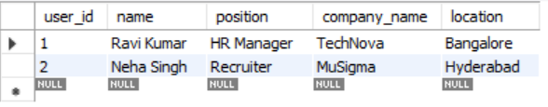

Table - Applications
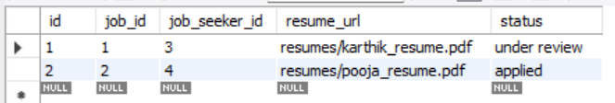

Table – Interview_Scheduled
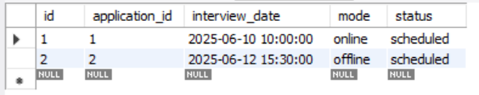

Table – Saved_Jobs
